**PROJECT REPORT**

Deep Learning Applications in

Medical Image Analysis

(recognizing the presence of tumor)

By

|  |  |  |
| --- | --- | --- |
| **S.No** | **Name** | **Class ID** |
| 1 | Rishitha Chowdary Bobba | 3 |
| 2 | Sai Divya Chennupati | 7 |
| 3 | Niteesha Kothinti | 20 |
| 4 | Naga Bindu Madamanchi | 21 |

**Github link :** <https://github.com/saidivyachennupati/python_project>

**Introduction:**

Brain tumor detection and classification is the most difficult and tedious task in the area of medicinal image preparing. MRI (Magnetic Resonance Imaging) is a medicinal procedure, generally adopted by the radiologist for representation of inner structure of the human body with no surgery. The tremendous success of machine learning algorithms at image recognition tasks in recent years intersects with a time of dramatically increased use of electronic medical records and diagnostic imaging. We cover key research areas and applications of medical image classification, localization, detection, segmentation and prediction. We conclude by discussing advantages, disadvantages and possible future directions.

**Motivation:**

* The tremendous success of machine learning algorithms at image recognition tasks in recent years intersects with a time of dramatically increased use of electronic medical records and diagnostic imaging.
* This project introduces the machine learning algorithms as applied to medical image analysis, focusing on convolutional neural networks, and emphasizing clinical aspects of the ﬁeld.

**Dataset:**

The dataset consists of two sets of data, training set of data and testing set of data. We used CNN (Convolutional Neural Network) model for the prediction purpose in the dataset.

**Modules:**

Importing Dataset:

* Initial step in our project is to import image dataset which are having both tumor contained images, and non tumor x-ray images.

Splitting the data:

* After importing the dataset need to split the data into two parts like training and testing datasets. Based on split size need to split the data.

Building neural networks:

* We need to feed the convolution neural networks with trained with different layers need to give, after that giving the testing the data for analyzing the result

Prediction:

* Finally give on x-ray image to neural networks it will checks that weather that image having tumor or not and then gives the result

**Architecture:**

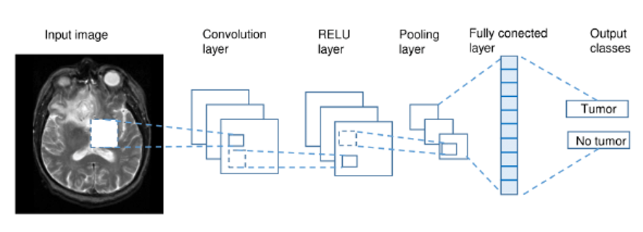

Approach –

* The data is collected and sorted into training and testing set.
* The model is trained using a CNN model.
* Firstly, the testing image is fed as the input to the convolution layer.
* The parameters are chosen and the filters are applied on the image.
* The necessary ReLu activation is given to the matrix.
* In order to reduce the dimensionality, pooling is done on the next step.
* For all the multiple layers, in order to determine the single output, flattening is done.
* Finally, the output is achieved after the model is fitted using necessary further procedures.

**Output pictures:**

* Fitting the model

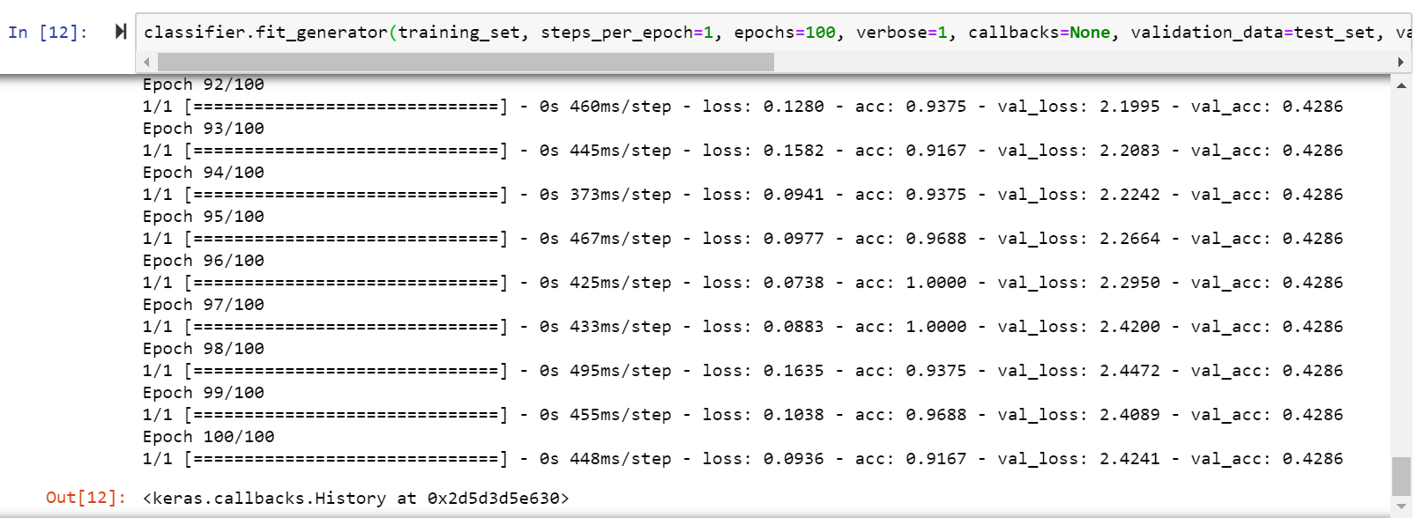

* Loading a test image

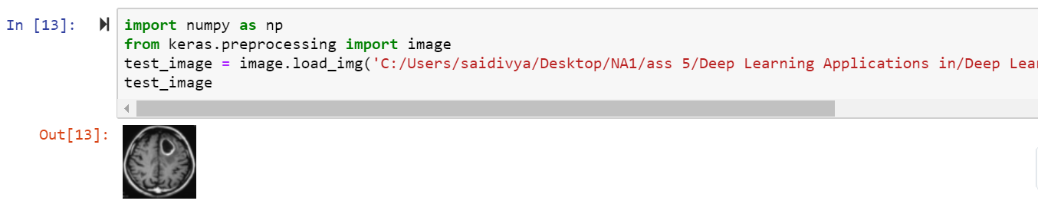

* The output is showing the type of tumor the test image consist.

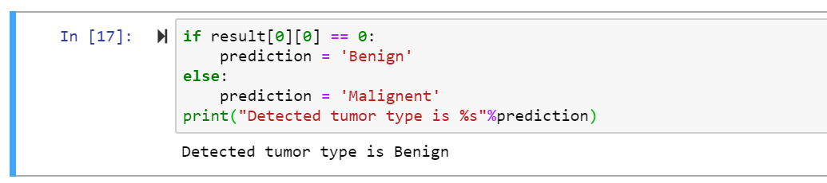

**Execution video:** https://drive.google.com/open?id=1szkXodkE13rGO2nl6y7AXWjBP7fUke0L

**Challenges faced:**

* The collection of necessary dataset that actually sets in for this project is very challenging because of sorting each and every image individually.
* The detection of the minor node module which is the major criteria for detection is complicated.

**Conclusion:**

The project includes the prediction of the presence of nodules within and around lung fissures. This is used to determine the type of tumor that a testing image consists of. The tremendous success of machine learning algorithms at image recognition tasks in recent years intersects with a time of dramatically increased use of electronic medical records and diagnostic imaging.

**Future enhancement:**

In this project we have seen the brain tumor prediction using CNN (convolution neural networks). The performance of the prediction rate is descent. In the process of developing this model we felt there is a scope for enhancement. Hence we want to show the possibilities how we need to enhance it.

The dataset we used have limited number of samples. If we can have images of different categories of brain tumor, there is a scope to predict every kind of tumor. (eg: Chordoma. CNS Lymphoma. Craniopharyngioma).

**References:**

* A. Foss and O. R. Za¨ıane, “A parameterless method for efﬁciently discovering clusters of arbitrary shape in large datasets,” in Pro- ceedings of ICDM. IEEE, 2002, pp. 179–186.
* <https://medium.com/@RaghavPrabhu/understanding-of-convolutional-neural-network-cnn-deep-learning-99760835f148>
* J. Lee, M. Podlaseck, E. Schonberg, R. Hoch, and S. Gomory, “Analysis and visualization of metrics for online merchandising,” in WEBKDD’99 Workshop.